**BLM Data Analysis**

**AMINAT BAKARE**

**Introduction**

Police brutality has been a problem in the United States for long. Most people believe that racial differences and poverty have increased the number of shootings by police in the country (Fagan and Campbell, 2020). As an election candidate, addressing issues that touch ordinary citizens' real lives is essential to them and increases their chances of getting elected. In this report, the police shootings dataset, household income levels data, and racial distribution data were analyzed to give our candidates facts to use when addressing the police brutality issues during the campaigns.

We wish to answer the following research questions;

1. Does race affect police brutality?
2. Is there a relationship between poverty and police brutality?
3. Can body cameras on police reduce cruelty?

**Extract, Transform, and Load**

Three datasets have been combined to help solve our data analysis problem. The datasets are cleaned using Excel software to ensure they are consistent, complete, and relevant before being loaded into Tableau software for analysis. Upon close investigation of the data, we realized that the Medium income variable had some rows with missing values and others with negative median income. Those rows were dropped from the dataset. In the racial discrimination dataset, some rows had X instead of importance in the share of race variables; they were all dropped. In the police killings data, the race variable had missing values in some rows. Those rows were dropped. The data was then loaded into Tableau software, and the three dataset tables were joined based on their standard variable, State.

**Data analysis**

The past step towards understanding any patterns and relationships in the data is to create a graph that shows us how police killings have been changing over time since 2015. The chart below shows the killings over time.

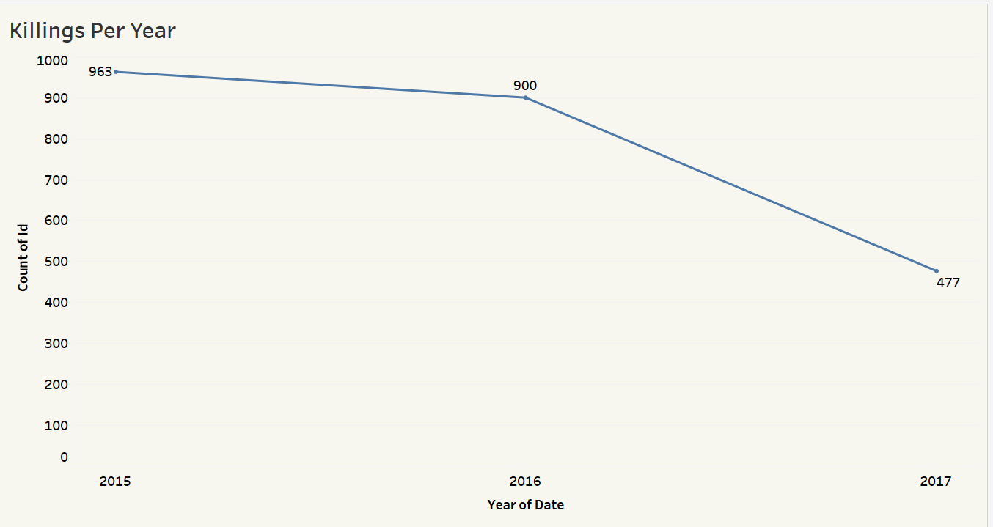

According to the chart, the number of people killed by police has been reducing since 2015, but it is still high in 2017. There was a significant decrease in 2016.

The chart below helps us understand the number of people killed by police grouped by race.

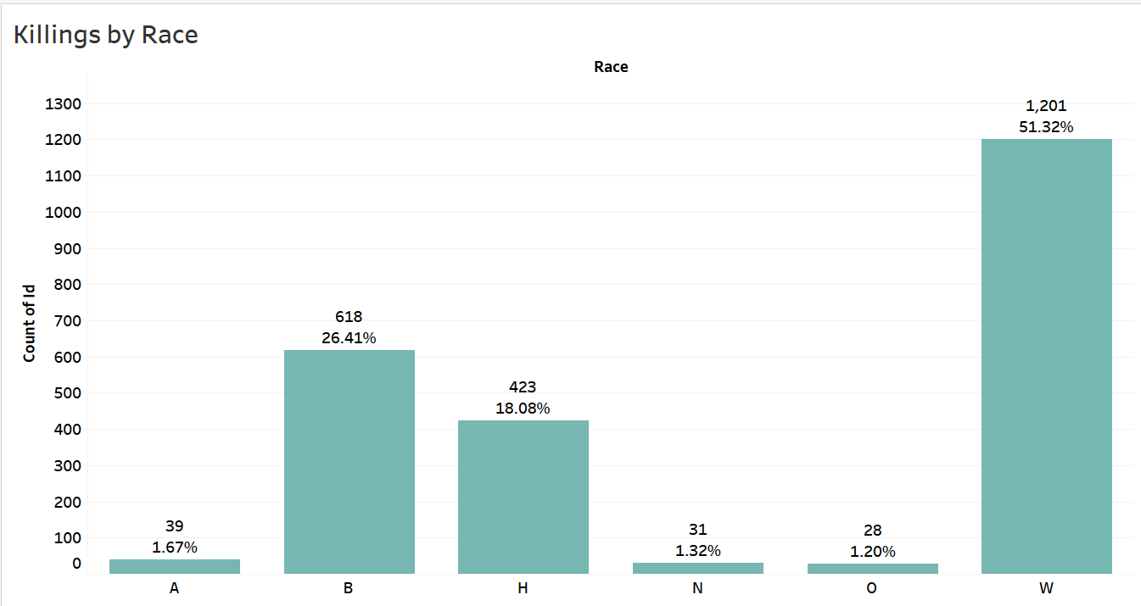

According to the chart, whites have the highest number of people killed by police (1201). The race with the second highest number of people killed by police is black (618), and the third is Hispanic (423). Although the number of whites killed is high, the number of blacks is relatively high given that only 13.6% of the total population in the US is black while white non-Hispanics are 59.3% (Arias and Xu, 2019).

The next step was looking at the killings by the state, as shown below;

Upon proper investigations, it was established that California had the highest number of police killings, followed by Texas, Florida, and then Arizona. The police killings in California had to be investigated more, as shown below.

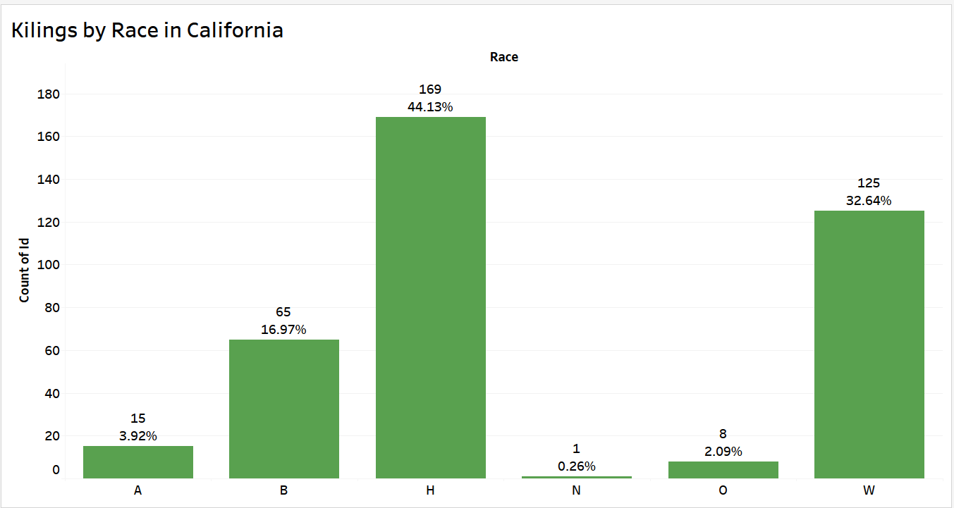

Upon looking at the killings in California by race, it was found that most of the victims were Hispanic, followed by Whites and then Blacks. There are so many Hispanic people in California so the high number of victims in the area was reasonable.

Now it is time to look at the cities with top police-related deaths in California state, as shown below.

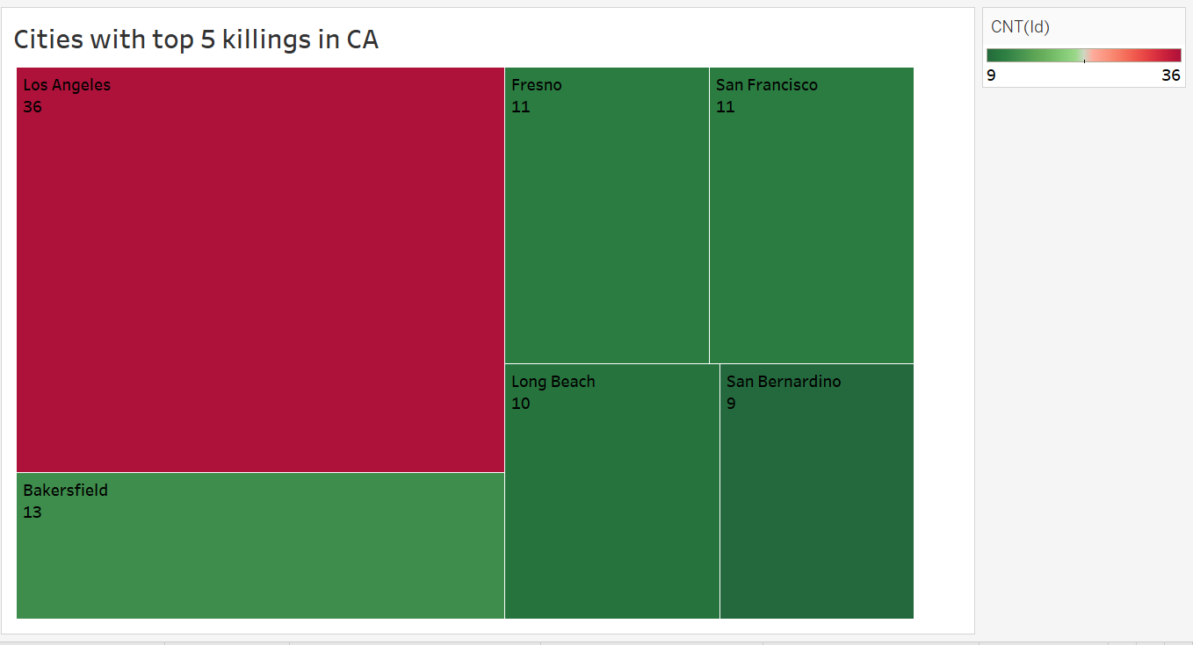

The chart shows that Los Angeles was leading with the high number of police related deaths.

In the chart below, we decided to look at the cities with the highest ratio of black population.

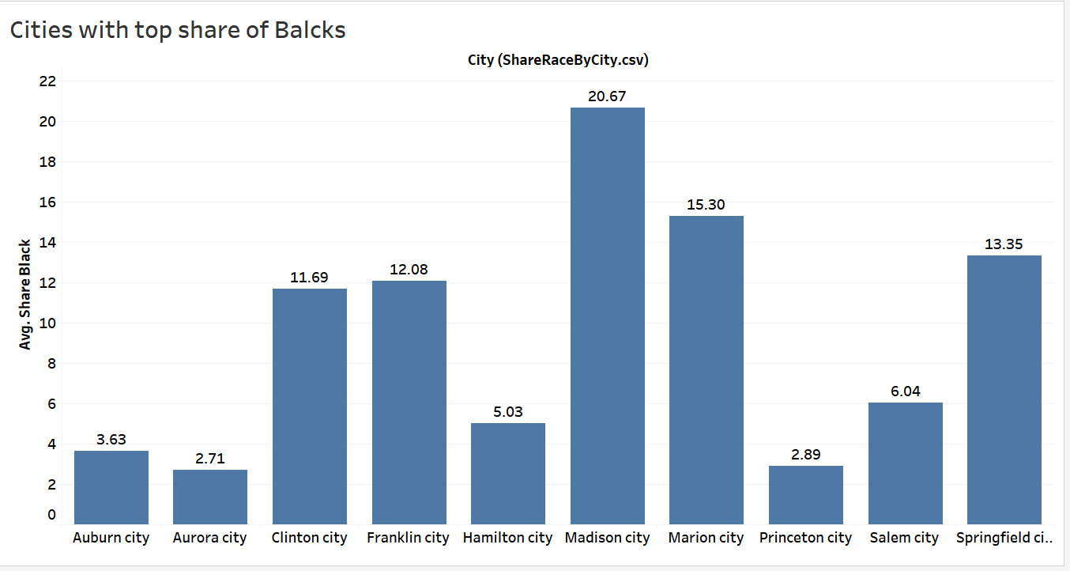

The figure shows that Madison City has the highest share of the black population, followed by Marion City.

The figure below shows the killings in cities throughout the country.

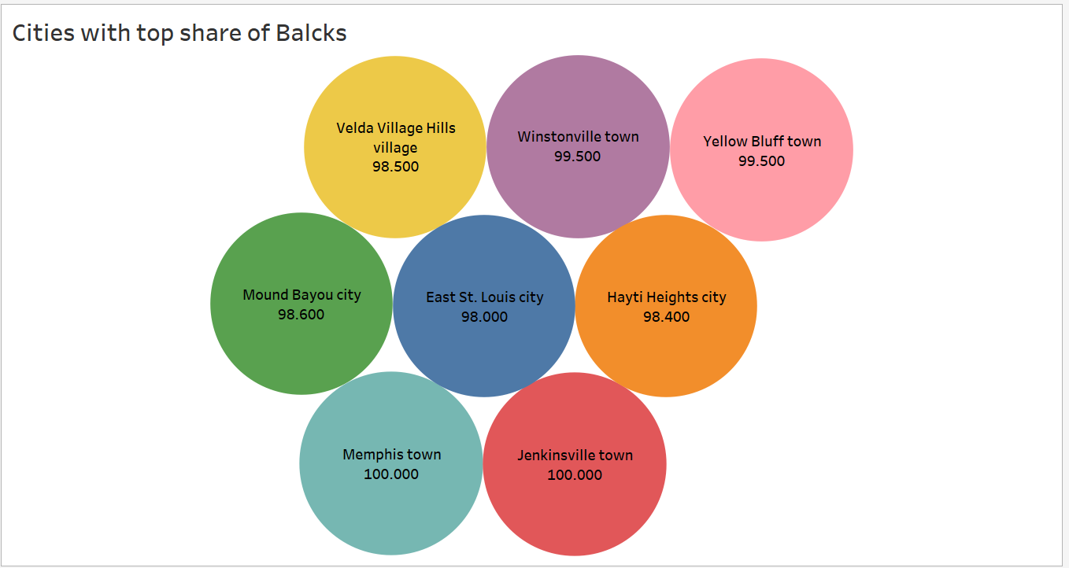

The figure shows that the cities that have the highest number of black populations do not appear in the cities with the highest number of killings. Therefore, although an earlier chart suggested that the percentage of blacks killed by police is relatively high, there is no evidence suggesting that blacks are targeted.

The chart below investigates if poverty may have any relationship with the killings.

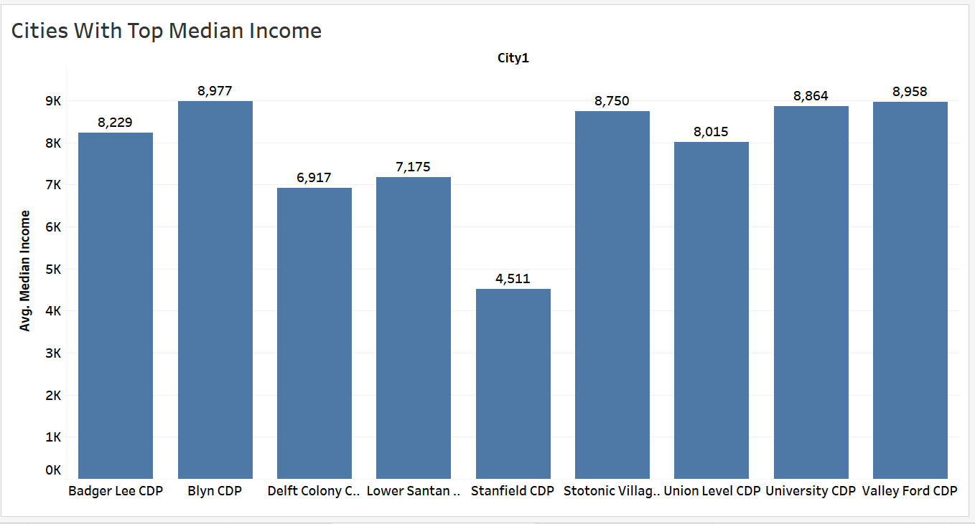

The figure above shows the nine poorest cities in the US. Not all cities in this figure are found in the cities with top killings. Therefore, we cannot suggest that the killings are high where there is poverty.

The figure below shows the police deaths when police had body cameras.

The chart shows that most of the deaths occur when police have no body cameras.

**Conclusion** The data does not contain evidence that police intentionally target citizens based on their race or income level. While some cities report high numbers of Hispanic and Black victims, these figures align with the racial demographics in those areas rather than indicating intentional targeting. However, the data strongly suggests that officers involved in fatal incidents are often those without body cameras. Additionally, regional variations in the data highlight the need for localized solutions, emphasizing fairness, accountability, and transparency in regulatory reforms. This analysis is particularly relevant to broader calls for justice, such as those advocated by the Black Lives Matter movement.

**Recommendations**

* Mandatory Body Cameras: Implement body cameras for all police officers to increase accountability and reduce incidents of police brutality.
* Localized Solutions: Tailor reforms to address specific regional variations in police-citizen interactions, particularly in high-incidence states such as California, Texas, Florida, and Arizona.
* Transparent Regulations: Develop and enforce transparent policies prioritizing fairness and accountability, ensuring public trust.
* Campaign Focus: The candidate should highlight these measures, especially in areas with high incidents, aligning with public demands for justice and equitable reforms.

**References**

Arias, E., & Xu, J. (2019). United States life tables: 2017.

Fagan, J., & Campbell, A. D. (2020). Race and reasonableness in police killings. BUL Rev., 100, 951.